**Types of Banks in the U.S. Banking System**

**Commercial Banks (National Banks)**

* These banks, such as community banks, accept deposits and offer business and consumer loans.
* They provide services like checking and savings accounts, loans, and insurance services.
* Examples include commercial banks that are chartered by the state and insured by the **Federal Deposit Insurance Corporation (FDIC)** and the **Federal Reserve Bank.**

**Sources of revenue**

* **Interest Income**: For the top national banks (e.g., JPMorgan Chase, Bank of America, Wells Fargo), the combined interest income was approximately **$450 billion.**
* **Non-Interest Income**: The combined non-interest income for these banks was about **$200 billion.**
* **Trading Revenue**: The trading revenue for top national banks was roughly **$50 billion.**

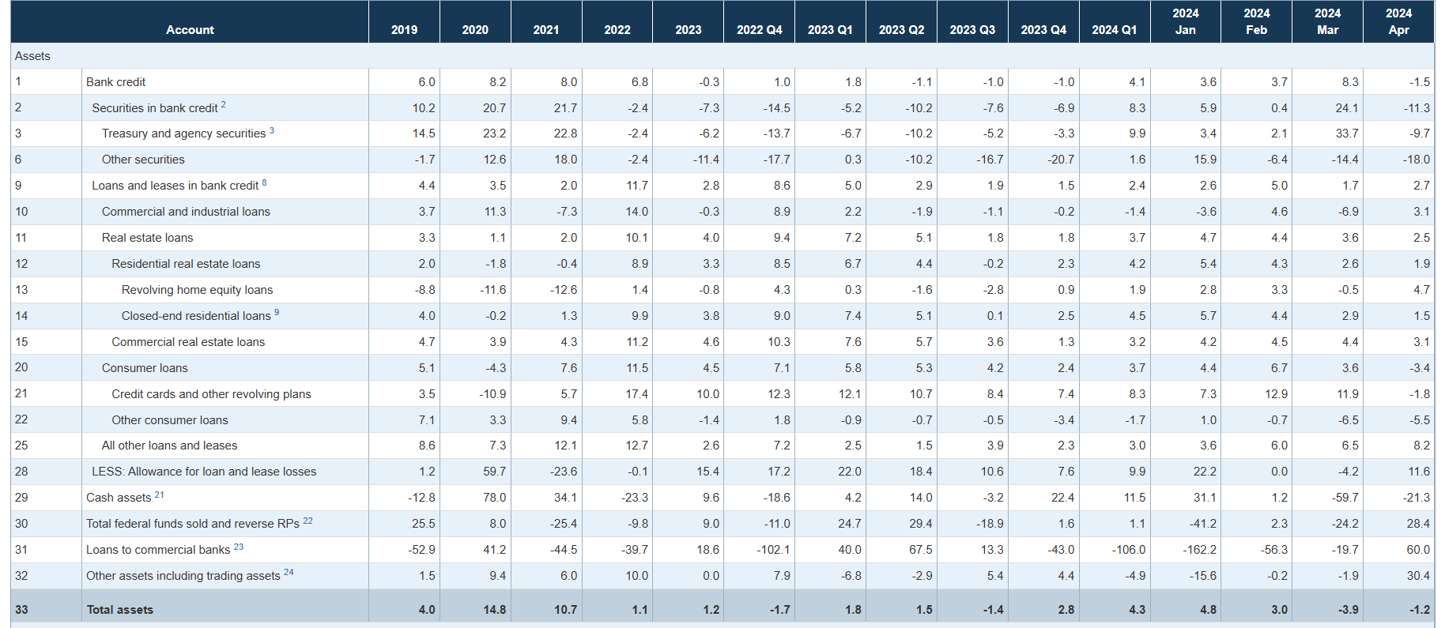

**Largest commercial banks in the United States in 2022, by revenue**

**(in billion U.S. dollars)**

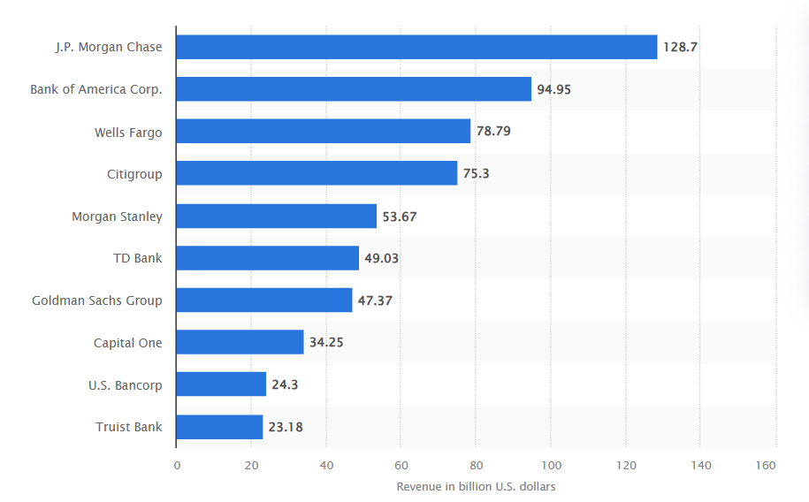

**Central Banks (Federal Reserve System)**

* These banks are investing members of the Federal Reserve System and are chartered by the United States of America.
* They offer global banking services and have branches in major cities and many states.
* They provide the same services as commercial banks, including money market accounts and trading bonds and stocks.

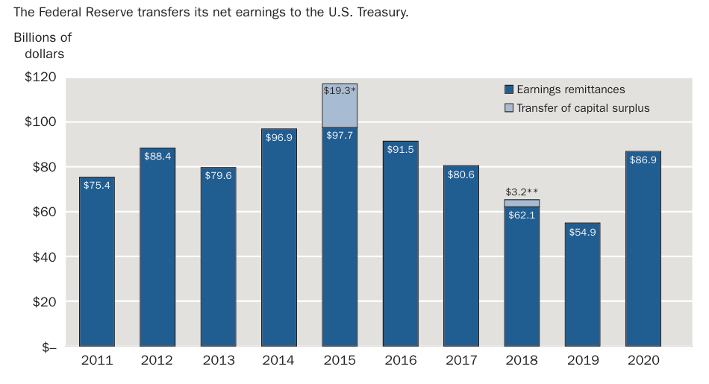

**Sources of revenue**

* **Interest on Securities**: The Fed earned approximately **$116 billion** in interest on U.S. government securities.
* **Interest on Loans**: The revenue from interest on loans to depository institutions was about **$500 million.**
* **Service Fees**: Revenue from financial services amounted to around **$450 million.**

**Credit Unions**

* These are not-for-profit organizations owned by members and overseen by a board of directors.
* employees of certain companies, religious institutions, or school districts.
* Credit unions offer similar services to commercial and national banks, with accounts up to **$250,000** insured by the FDIC and the National Credit Union Share Insurance Fund (NCUSIF).

**Value of assets of credit unions in the United States from 2013 to 2022(in trillion U.S. dollars)**

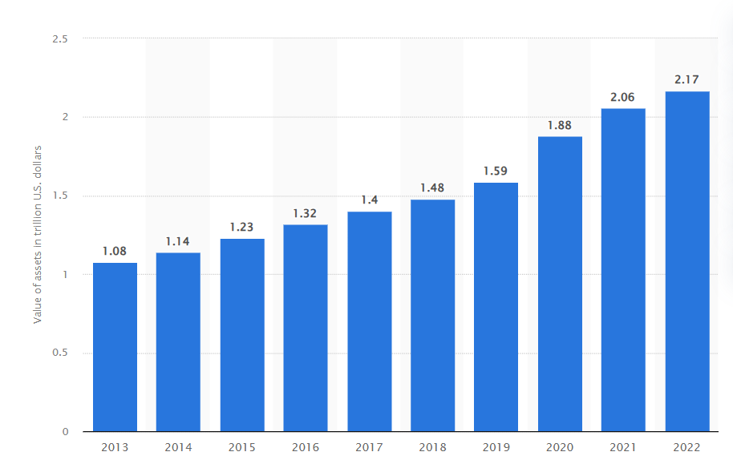

**Sources of revenue**

**Interest Income**

* **Loans to members**: This includes auto loans, mortgages, credit card loans, personal loans, and other consumer loans.
* **Investments**: Income from securities, government bonds, and other investment vehicles.

In 2023, interest income typically represented around **70-80%** of total revenue for credit unions.

**Total interest income**: $50 billion

* Loans to members: $40 billion
* Investments: $10 billion

**Fee Income**

* **Service fees**: Charges for account maintenance, overdrafts, ATM usage, and other banking services.
* **Transaction fees**: Fees associated with wire transfers, foreign transactions, and other similar services.

Fee income generally accounts for about **10-20%** of the total revenue.

**Total fee income**: $10 billion

* Service fees: $7 billion
* Transaction fees: $3 billion

**Other Income**

Other income includes miscellaneous sources such as:

* **Non-interest income**: Income from activities like insurance commissions, investment sales, and other non-traditional banking services.
* **Gains on sales of assets**: Profits from selling securities or other assets.
* **Miscellaneous income**: Includes any other income not categorized above.

Other income usually makes up about **5-10%** of total revenue.

**Total other income**: $5 billion

* Non-interest income: $3 billion
* Gains on sales of assets: $1 billion
* Miscellaneous income: $1 billion

**Investment Banks**

These banks are responsible for corporate-level investing activities, including handling commodities, foreign transactions, and securities. They may also be involved in acquisitions and mergers or trading derivatives. Investment banks must comply with consumer, federal, and state regulations.

**Advisory Fees (Mergers & Acquisitions)**

Investment banks earn advisory fees by guiding mergers, acquisitions, divestitures, and other financial transactions. This is a significant revenue stream, especially during periods of high M&A activity.

**Example:** In 2022, global M&A advisory fees totaled approximately $46 billion, with U.S. banks like Goldman Sachs, JPMorgan Chase, and Morgan Stanley capturing a substantial portion of these fees.

**Underwriting Fees (Equity and Debt Offerings)**

Investment banks underwrite equity and debt offerings, earning fees for their services in raising capital for corporations through initial public offerings (IPOs), secondary offerings, and bond issuances.

**Example:** In 2022, the underwriting fees for IPOs in the U.S. amounted to around $7 billion. Despite a slower IPO market in some years, debt underwriting remains robust, contributing several billion dollars annually.

**Trading Revenues**

Revenues from trading activities, including market-making, proprietary trading, and trading on behalf of clients, form a significant part of an investment bank's income. This includes equities, fixed income, currencies, and commodities (FICC).

**Example:** In 2022, the top five U.S. investment banks (Goldman Sachs, Morgan Stanley, JPMorgan Chase, Bank of America, and Citigroup) collectively generated around $85 billion in trading revenues.

**Asset Management Fees**

Investment banks with asset management divisions earn fees by managing assets for institutional and retail clients. This includes mutual funds, hedge funds, private equity, and wealth management services.

**Example:** In 2022, asset management fees for major U.S. investment banks contributed approximately $30 billion in revenues.

**Principal Investments**

Revenue from principal investments includes profits from the bank's own investments in various financial instruments, real estate, private equity, and other assets. This source can be volatile, depending on market conditions.

**Example:** Principal investment revenues can vary widely; however, in good years, it can contribute several billion dollars to a bank's total revenue.

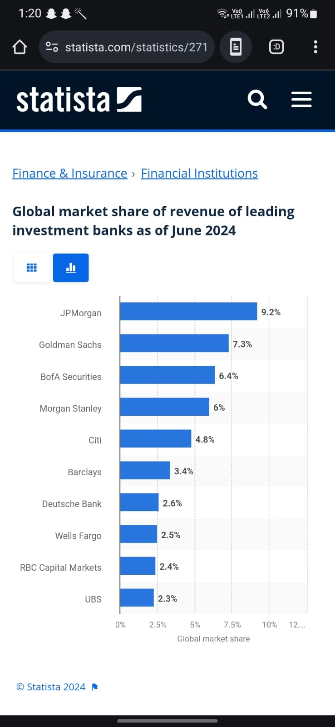

**Breakdown of Revenue Sources for Leading U.S. Investment Banks (2022)**

**Goldman Sachs (2022)**

* Advisory Fees: $5 billion
* Underwriting Fees: $3 billion
* Trading Revenues: $25 billion
* Asset Management Fees: $8 billion
* Principal Investments: $2 billion
* Total Revenue: $43 billion

**JPMorgan Chase (Investment Banking Division, 2022)**

* Advisory Fees: $4 billion
* Underwriting Fees: $2.5 billion
* Trading Revenues: $20 billion
* Asset Management Fees: $6 billion
* Principal Investments: $1.5 billion
* Total Revenue: $34 billion

**Savings Banks**

These banks were initially established to provide services for lower-income workers, offering higher interest rates than commercial banks but fewer services.

They have become more like commercial banks in recent years, offering a wider range of services.

**Savings and Loans**

These institutions were established to make it possible for lower-income workers to buy homes.

They offered savings accounts and made loans for home purchases. Many of these institutions became insolvent and were bailed out by the government in the 1980s.

**Sources of Revenue**

**Interest Income**

* **Mortgage Loans:** The primary source of revenue is the interest earned on mortgage loans. S&Ls typically offer long-term, fixed-rate mortgages to homeowners.
* **Consumer Loans:** In addition to mortgages, S&Ls also generate revenue from other types of consumer loans, including auto loans and personal loans.
* **Investment Securities:** Interest earned from investment in government and corporate securities.

**Fees and Service Charges**

* **Loan Origination Fees:** Fees charged to borrowers for processing new loans.
* **Account Maintenance Fees:** Monthly or annual fees for maintaining accounts.
* **Late Payment Fees:** Fees collected for late payments on loans and mortgages.

**Other Income**

* **Real Estate Owned (REO):** Income from the sale of properties owned by the institution due to foreclosure.
* **Commissions and Other Financial Services:** Revenue from offering various financial services, such as insurance and investment products.

**Financial figures from the S&L industry based on data from recent years**

**Total Assets:**

* As of the end of 2022, S&Ls in the United States held approximately $1.2 trillion in total assets.

**Net Interest Income:**

* In 2022, the net interest income (the difference between interest earned on assets and interest paid on liabilities) for S&Ls was around $40 billion.

**Fee Income:**

* Fee and service charge income accounted for about $5 billion in 2022.

**Net Income:**

* The aggregate net income for the S&L industry in 2022 was approximately $10 billion.

**Loan Portfolios:**

* S&Ls held around $900 billion in mortgage loans as part of their portfolios at the end of 2022.

**Interest Rates:**

* The average interest rate on a 30-year fixed-rate mortgage offered by S&Ls was approximately 3.5% in 2022, though this rate has likely varied with market conditions.